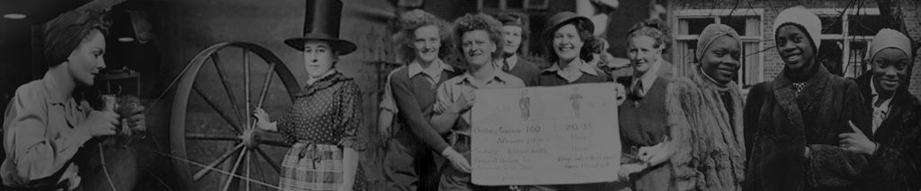

West of England and South Wales Women’s History Network
29th Annual Conference
Women and Money: A Historical Perspective
Saturday 15th October 2022
Venue: Friends Meeting House
Champion Square, St Pauls
Bristol BS2 9DB
Call for Papers
Keynote Speaker
Dr Helen Doe, University of Exeter,
'Women in Business or Businesswomen?'

We invite papers on any aspect of the history of Women, Gender and Money. The relationship between women and money is defined in its broadest sense to cover a variety of spheres, including homes, streets, workplaces, public institutions or civic society. Topics could include, but are not limited to, women gender and:
- Managing money (eg. credit, banking, household budgeting)
- Making money (eg.trading, investing, managing a business}
- Earning money (eg.work, wage bargaining, equal pay)
- Financial survival (eg. cost of living, navigating the Poor Law, survival strategies of the poor, pawnbroking, credit)
- Economic protest (eg. cost of living protests, wage strikes, food riots, boycotts, ethical shopping)
- Financial support for organisations and movements (eg fund raising, donations, hospitality)
Papers should be of not more than 20 minutes in length. Suggestions for presentations in film or other non-standard formats will be considered.
Please send an abstract of up to 300 words to Jane Howells mail@sarum-editorial.co.uk by Monday 25 April 2022

