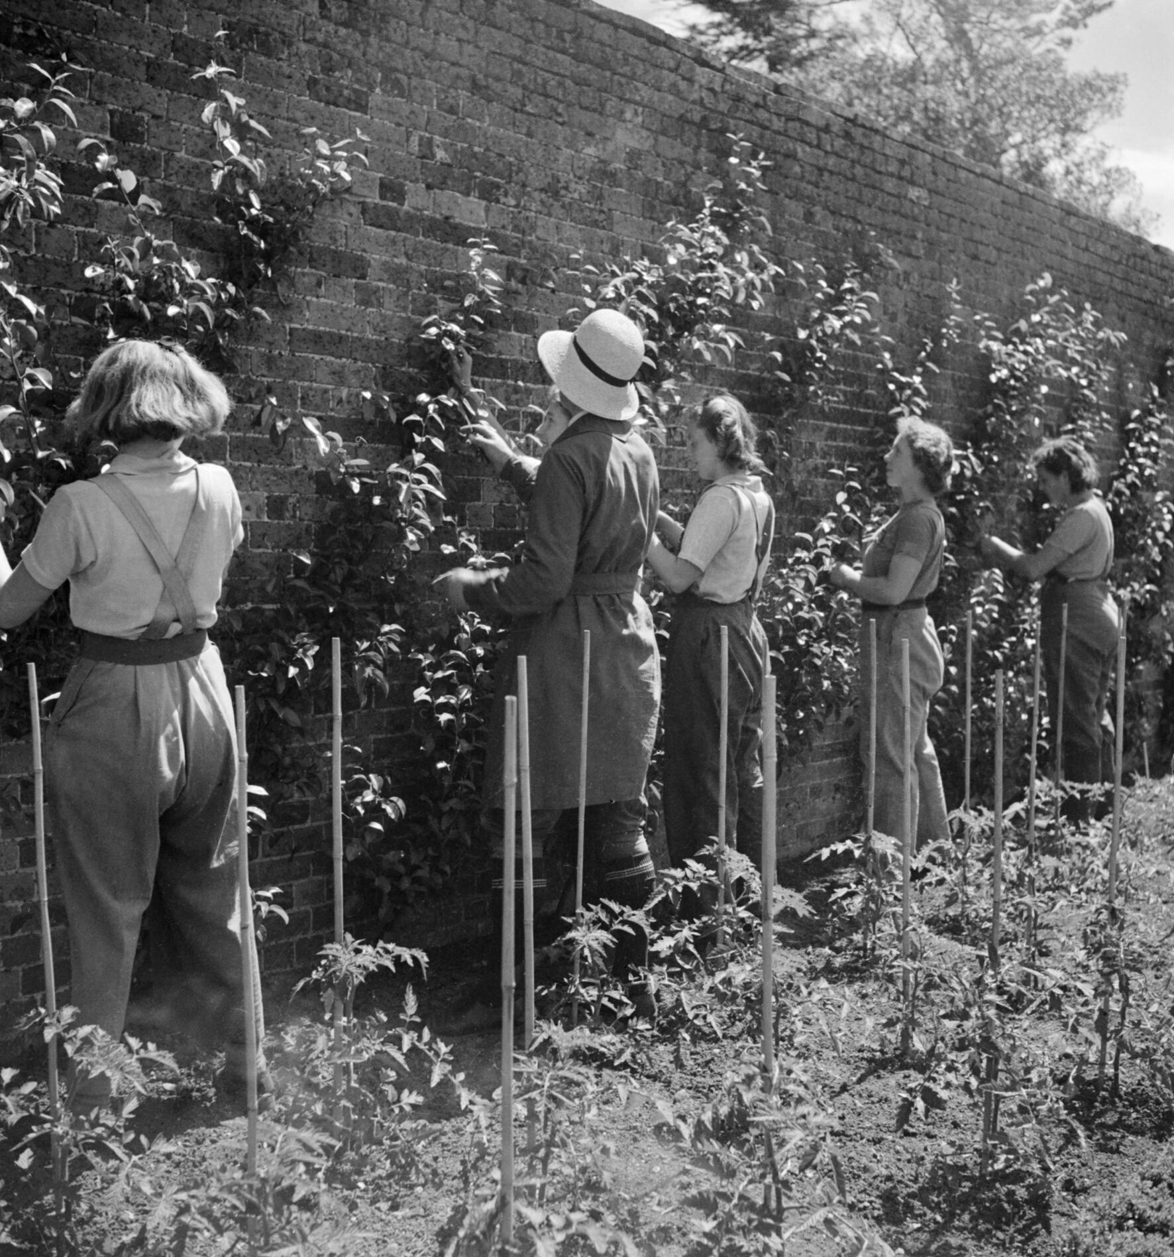
West of England and South Wales
Women's History Network
Work in Progress Study Morning
and AGM
Women, Health and Wellbeing
Saturday December 4th, 2021
10am to 12.30pm
This event is free of charge and will be held on Zoom

10 am Welcome
Diana Russell, ‘Healing Hands, women and private health care in Bath c.1911-1928.'
Karen Moore, ‘Teaching the Plymouth Mermaids: Madame Gent, Plymouth Swimming Teacher, 1880 – 1904’

Penny Bayer, ‘Edna Gunnell, Devon County Council Horticultural Superintendent, and the Women Gardener movement.’

11.20 Coffee break and networking time

11.50 AGM

12.30 Close

For further information and to register attendance contact katherineuna.holden@gmail.com

