West of England and South Wales Women’s History Network
28th Annual Conference
Saturday 16th October 2021 10am to 4.00pm
Gender and Commemoration
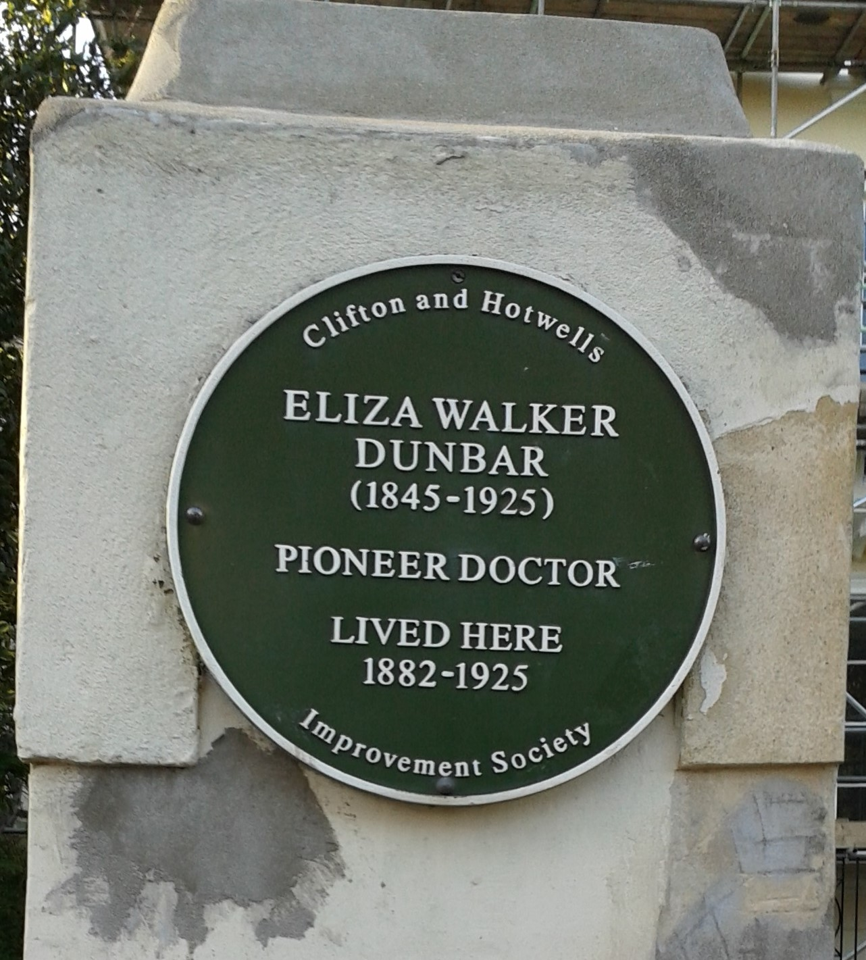
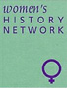
Due to COVID numbers this event will be on Zoom and is free of charge but booking essential – see below for link
10 am Welcome
Keynote Speaker: Carrie de Silva, Consultant / Independent Scholar
BFWG Scholarship Trust Chair, Sybil Campbell Collection Trustee
Carrie will discuss women celebrated in street names and the consequences of the persistence of cultural norms in public commemoration of women’s lives.
11 am Coffee
11.30 am Strand 1 Commemorating Women’s Movements
Lucienne Boyce ‘This cause of confusion should be removed’: Suffragists and Suffragettes’.
Elaine Titcombe, ‘Greenham at 40: Commemorating Women’s Protest’
Mari Takayanagi, ‘Vote 100: Marking a suffrage centenary in the UK Parliament’.
11.30am Strand 2 Forgotten Women: Individuals Remembered
Hilary Slack, University of Wales Trinity St David, ‘A reformer in her own right: Mary Knibb wife of William Knibb, abolitionist and social reformer’.
Kensa Broadhurst, University of Exeter, ‘Dolly Pentreath: a “very singular female.’
Chiara Antico, Universidade NOVA de Lisboa, ‘Alma Rosé’s Interrupted Life: Narrating Her Story, Commemorating Her Music’.
Lunch 1pm
2pm Strand 3 Forgotten Women: Brought into the Light
Julie Davies, ‘Commemoration of Professional Nurses After the Great War’.
Alexander Scott, University of Wales Trinity St David, ‘Rethinking the Bicentenary of Lampeter’s University: Gender History Perspectives’.
Daria Pola Drazkowiak, ‘Trinity College Dublin, The Art of Memory – Female Posthumous Commemoration in Fifteenth Century Florence’.
2pm Strand 4 Forms of Commemoration
Kate Brooks, Bath Spa University, ‘Still seen but not heard: Bristol young people in care today, responding to the history of Muller’s Orphan Homes, Bristol’.
Jennifer M. S. Stager and Leila Easa, Johns Hopkins University, ‘Overwriting the Monument Tradition’.
Maureen Fielding Penn State University, ‘Commemorating “Comfort Women” though Artwork, Memorials, and Ekphrastic Poetry’.
3.30 pm Closing Remarks To book go to http://weswwomenshistorynetwork.co.uk/

