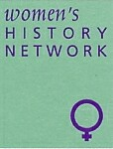

West of England and South Wales

# **Women’s History Network**

## NEWSLETTER MAY 2019

**Co - Chairs:** Kath Holden and June Hannam **Membership Secretary:** Elaine Titcombe

**Treasurer:** June Hannam **Publicity:** Lucienne Boyce **Newsletter editor:** Jane Howells

**Committee:**  Karen Hunt, Diana Russell

**West of England and South Women's History Network   
26th Annual Conference supported by UWE Regional History Centre, and AGM**

**Saturday 29th June 2019, 9.30 am – 5.15 pm**  
The University of the West of England, Frenchay Campus, Coldharbour Lane,

Bristol BS16 1QY

**Histories of Women in Agriculture and Rural Life**

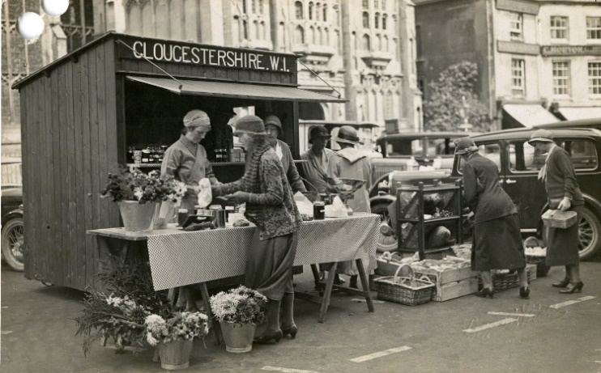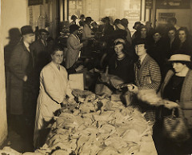

**Programme**

**9.30 Registration  
9.50 Welcome Note**

**10.00 Keynote: Professor Nicola Verdon,** author of *Rural Women Workers in 19th century England*

**11.00 – 11.30 Coffee break**

**11.30**

**Valerie Brenton**, Dusting and Digging: The revelations of a wage ledger 1796-1829.

**Carrie de Silva,** The agricultural education of women from the 1880s to 1939.

**Jacqueline Sarsby**, Early farm tourism, borders and farm servants 1910 – 1950.

**1.00 Lunch**

**2.00 Back to the Land**

**Katherine Holden, Diana Russell and Elaine Titcombe**, in conversation with Lucienne Boyce, sharing their own experiences and family histories of women in agriculture and rural life.

**2.45**

**Julia Neville**, Exploring women’s lives in the ‘Deserted’ village in 1920s Devon.

**3.15 Coffee break**

**3.30**

**Kate Luck,**The early development of Wiltshire’s ‘Women on the Land Movement’ during the Great War. Can Town Girls be taught to milk?

**Lisa Payne Ossian,** The emergency famine of 1946: An examination of farm women’s production and perceptions.



**4.30 Closing Remarks**

**4.45 – 5.15 AGM** All Welcome

**[](https://www.google.com/imgres?imgurl=https%3A%2F%2Fupload.wikimedia.org%2Fwikipedia%2Fen%2Fthumb%2F1%2F11%2FUWE_Bristol_logo.svg%2F1280px-UWE_Bristol_logo.svg.png&imgrefurl=https%3A%2F%2Fen.wikipedia.org%2Fwiki%2FFile%3AUWE_Bristol_logo.svg&docid=rAta4kuoERqtWM&tbnid=-Fa_b11J0izJXM%3A&vet=10ahUKEwjQivqBio_iAhW1URUIHcB-CD0QMwhAKAAwAA..i&w=1280&h=627&bih=603&biw=1280&q=uwe%20logo&ved=0ahUKEwjQivqBio_iAhW1URUIHcB-CD0QMwhAKAAwAA&iact=mrc&uact=8)**For more information please email:[**WHNWESTSWALES@outlook.com**](mailto:WHNWESTSWALES@outlook.com)

Web site:[**http://weswwomenshistorynetwork.co.uk/**](http://weswwomenshistorynetwork.co.uk/)

***The booking form can be found at the end of this newsletter.***

Regional History Centre

### **Other forthcoming Regional Network events**

We are planning to run a study day in the Autumn, further details will be on the website as soon as arrangements are confirmed.

The regional network exists for its members. Do let us know if you have any particular interests for topics and /or suggestions of potential contributors (and venues) for Study Days, or any alternative ideas for different events or activities.

**NEW: Bridport’s Women’s History Group**

Last November there were a series of women’s history events in Bridport, which included a talk on Women’s Suffrage in Dorset (the first one sold-out so it was repeated by popular demand!); a study day on Bridport Women’s Activism, 1910-20 (supported by WESWWHN); and a series of 5 afternoon talks about Women on Bridport’s Home Front, 1914-19. It seemed 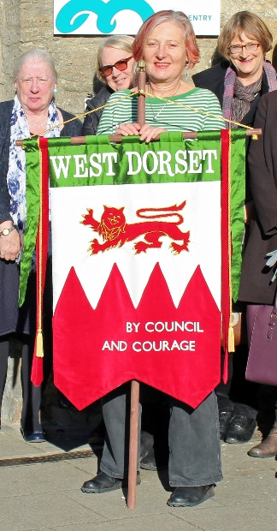only appropriate given the focus on the vote, to hold a ballot at each event to see if there was sufficient interest in the town to form a Women's History Group. There was, and finally it's happening!

The inaugural meeting of **Bridport’s Women’s History Group** will be on 9 May upstairs at Bridport Youth and Community Centre, Gundry Lane at 7pm. The idea is then to continue to meet on the 2nd Thursday of the month (with August off for good behaviour!). BWHG will provide a space to share research on the histories of women from any period or place. To begin with there will be a series of talks followed by discussion, but there is also the possibility to 'do women's history' if some in the group want to take that on. One idea is to create a women's history walk around Bridport. An initial programme has been put together. If you want to offer a talk; can suggest someone else who could talk about some aspect of their women's history research; or have a topic you would like to hear about, then you are asked to let Karen Hunt know (k.hunt@keele.ac.uk).

At the first meeting, Karen Hunt will talk about sexual scandal and gossip among socialists

and feminists at the turn of the C20 and the gendered effects on the public and private lives

of those involved in **'When Dora Montefiore met George Belt.....'.** Future meetings include

talks on St Wite, the Goddess of Dorset; Women’s Networks in Early Nineteenth Century

Bridport - discoveries from the diaries of Maria Carter 1818-1834; using DNA to do women’s

history research; as well, we hope, contributions from a number of WESWWHN stalwarts on

the Greenham Common women, Labour women organisers, and something from the many

delights of Lucienne’s research. When the programme is finalised, it will appear in the

WESWWHN Newsletter. Meanwhile, if you want to know more, please contact Karen Hunt

([k.hunt@keele.ac.uk](mailto:k.hunt@keele.ac.uk)).

***Photo:*** *Some of the participants at the Bridport Women’s Activism Study Day outside Bridport Museum with the recreated banner of the local West Dorset Women’s Suffrage Society.*

**CALL FOR PAPERS**

**[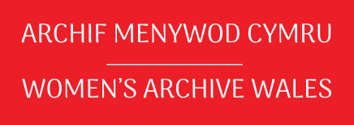](https://www.womensarchivewales.org/en/)**22nd Annual Conference

Saturday 5th October to Sunday 6th October 2019

St Fagans National Museum of History, Cardiff CF56XB

Papers are invited on any aspect of the history of women in Wales for inclusion in the conference programme from historians, archivists and others interested in promoting women’s history in Wales. Proposals from new researchers and students will be especially welcome. As we are working in partnership with St Fagans National Museum of History this year, we would particularly welcome papers on the history of women’s arts and crafts and female artists. We welcome both English and Welsh language papers.

Papers can vary in length from 15 minutes to 45 minutes, though most will probably be in the region of 30 minutes. Contributors should send an abstract of approximately 150-200 words outlining the key themes to be covered.

Submissions should be made by Friday 17th of May 2019. Please email your abstracts or queries to: [conference@womensarchivewales.org](mailto:conference@womensarchivewales.org)

Further details can be obtained from the Women’s Archive of Wales website: [www.womensarchivewales.org](http://www.womensarchivewales.org)

**Gender in Modern Welsh History Symposium**

**Date:** 11 September 2019  
**Location:** Cardiff University

This one-day symposium aims to bring together early career researchers and established scholars who work on any aspect of the history of gender in nineteenth and twentieth-century Wales. It will seek to interrogate gender as a concept which encompasses both femininity and masculinity, to provide fresh perspectives on familiar themes, and to encourage delegates to consider how gender can transform broader narratives in histories of Wales.

Significant advances have been made in the field of Welsh women’s history since Deirdre Beddoe’s eminently quotable claim in 1981 that if ‘a creature from outer space landed in Wales and worked through Welsh history, she would be perplexed as to how the Welsh procreated’. Pioneering research by historians such as Beddoe, Angela V. John and Ursula Masson has deepened our knowledge of the experiences of women in Wales’s past and how they intersected with national, religious and political ideologies. Masculinity, too, has come under increasing scrutiny since the publication of Paul O’Leary’s call for studies of male identity. This event will reflect on these historiographical developments during the last three decades, while also considering the gaps that remain. We welcome proposals for 20 minute papers on aspects of gender in modern Welsh history. Topics may include, but are not limited to, the following themes:

* Gendered intersections of race, ethnicity and class
* Gender, sexuality and the body
* Gender and disability
* Gendered structures of migration
* Cisgender and transgender identities
* Religion, language and education
* Paid and unpaid work
* The family
* Politics, protest and gender
* Gendered spaces and material cultures
* ‘Four nations’, regional and comparative methodologies

We hope to publish a selection of revised papers as an edited collection.

Please send c.200 word abstracts to Stephanie Ward ([wardsj2@cardiff.ac.uk](mailto:wardsj2@cardiff.ac.uk)) and Beth Jenkins ([b.jenkins@essex.ac.uk](mailto:b.jenkins@essex.ac.uk)) by **7th June 2019.**

**Other events of interest in the region**

* **Melanie King, ‘The tangled lives of two female spies!’**

Swindon Central Library, Regent Circus, Swindon SN1 1QG

17 May 2019 - 7pm, £6 (£5)

“Mention female spies, and most people think of Mata Hari. But during the Roaring Twenties, two strong-willed, independent, and highly ambitious women unafraid of taking risks, were a cause célèbre of the time, their names splashed across newspapers around the world. Marguerite Harrison was a highly respectable America socialite and Stan Harding was a runaway bohemian artist and dancer.

Almost a century later, it is easy to understand the fascination with these two remarkable women. Dodging bullets and interviewing colourful characters in war-torn Europe, the fateful meeting of these two intrepid women had repercussions that spanned three decades, involving heads of state and politicians in Britain, the United States, and Soviet Russia. Writer and historian, Melanie Kingis the author of six books, and now, *The Lady is a Spy*.”

* **Hallie Rubenhold, ‘The Ripper’s Women’**

Bath Assembly Rooms, Bennett Street, Bath BA1 2QH

24 May 2019 – 10.45am, £9

<https://bathfestivals.org.uk/the-bath-festival/event/the-rippers-women/>

“Hallie Rubenhold’s new book, *The Five*, unearths the stories of the victims of the Victorian Age’s most sensational crime: the 1888 murder spree of Jack the Ripper. She talks to Caroline Sanderson about the five women’s lives and their tragic, untimely deaths.”

* **Wil Aaron, ‘Martha Hughes, Cannon of Llandudno, the first woman senator of the United States’**

National Eisteddfod of Wales, Sir Conwy 2019

9 August 2019 – 1pm.

*(simultaneous translation)*

**Research News**

**Earnest and Able Women: the Devon Suffrage Activists Research Project**

**Dr Julia Neville, Devon History Society**

In November 1897 a local Devon newspaper welcomed the fact that the Devon Liberal Federation had rejected proposals for giving women the Parliamentary vote (*Western Morning News*, 20 November 1897). It warned, however, that there was ‘a powerful body, composed of earnest and able women … carrying on an active agitation in favour of women’s suffrage … all the more potent because the work is being done through private influence as well as by public meetings’.

First findings from the Devon History Society (DHS) Devon Suffrage Activists research project suggest that the editor was quite right in his perception, and that it was to be as true in the 1910s as it had been in the 1890s. The Devon women were indeed ‘earnest and able’, not just in their dedication to the cause of woman suffrage, but in what they did to carry out their belief that the vote was needed not only as a matter of justice but in order to change what they thought was wrong with the world. They did pursue their aim of enfranchisement through public education and by demonstrating their fitness to vote by accepting public office. However, they also used their position and their social networks for informal persuasion. Tennis and golf clubs, the Farthing Breakfast or Sale of Work stall, the art class and the literary society, Temperance and RSPCA meetings; these were all places where women met men (voters) and other women, and where they talked.

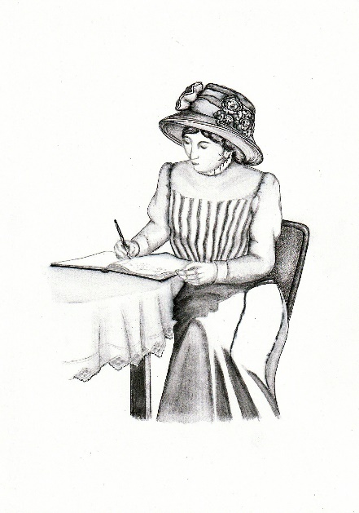

The Devon Suffrage Activists project, now nearing its end, began with the idea to hold a DHS conference, *How the Vote was Won in Devon*, to celebrate 100 years since the passing of the Representation of the People Act, 1918. Members, and interested parties from other history groups, were invited to join a group to research the backgrounds of the Devon women active in the suffrage movement between 1866 and 1918. The intention was to focus on Devon residents, not on the organisers despatched by the central offices of suffrage societies on whom so much attention had already been focused.

Fifteen people signed up to investigate women identified initially through Elizabeth Crawford’s *The Women’s Suffrage Movement in Britain and Ireland; a Regional Survey* (2006). This has been our principal guide, though we have added a substantial number of names from different sources. We have now identified more than 120 women the county who met our definition that to qualify as a Devon Suffrage Activist a woman should have held office in a branch, spoken at campaigning meetings, written letters or signed petitions, joined a protest, broken the law to further the cause, or lobbied MPs and candidates personally. In other words, they must have been publicly visible in their support for the cause.

The next idea was to create a Google map which would show the distribution of the activists across the (very large) county of Devon and put it up on the DHS website. Figure 1 shows the map, accessible at <https://www.devonhistorysociety.org.uk/research/suffrage-activists-in-devon-1866-1918/>. This map and the linked mini-biographies of each woman listed were launched on 6 February 2018, the actual anniversary of royal assent to the Representation of the People Act. The launch, illustrated by details of four of the women researched, received positive local and national publicity. Exeter’s *Express and Echo* was particularly interested as we were able to tell them that one of the activists had been the first woman columnist on their paper.

*How The Vote was won in Devon* took place at the University of Plymouth in April. With a winning combination of the map, national and local speakers, a women’s choir, twenty-four poster presentations, an original Suffrage Society banner and a rolling slideshow naming all the women (and some of the men) involved, the event generated positive feedback and some new members for the society.

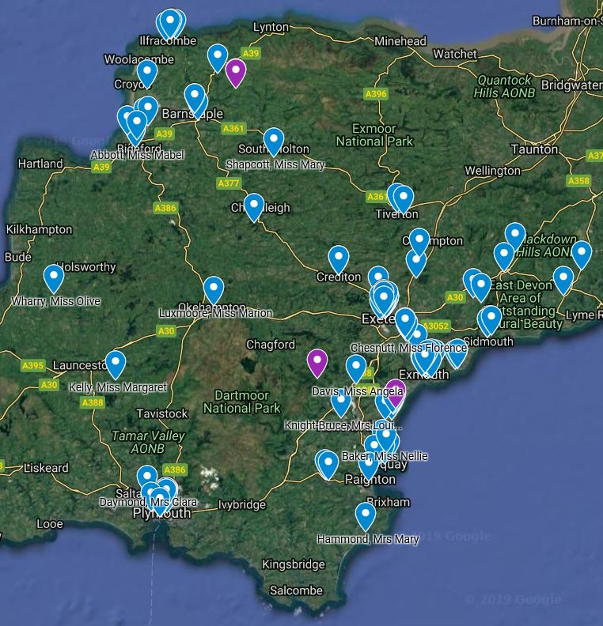

Figure 1

Meanwhile the on-line map and mini-biographies had attracted the attention of other individuals and groups. One relationship forged in this way was a link with Historic England (HE). Liz Clare, Local Engagement Advisor, got in touch to explore whether there was a way in which DHS could contribute to the HE 2018 project *HerStories.* With facilitation from Liz, the research group reconvened and decided to develop fuller biographies for the activists we had found, and then to link the entries on the DHS website where appropriate to buildings on the HE listings. We identified sites (homes, sites of activity or other buildings such as churchyards) related to about one third of our activists. We created links (through the HE Enriching the List facility) from the entries for the buildings to the DHS website biographies. When these were complete our initiative was launched by HE on 14 December 2018, the day the first women cast their votes in a Parliamentary election.

The webpage, <https://historicengland.org.uk/whats-new/in-your-area/south-west/nine-places-that-tell-the-story-of-suffrage-activism-in-devon/> shows how this works.

We have followed up the idea of enriching existing maps and listings now by a new partnership with the South West Heritage Trust linking the women’s biographies as a collection on the on-line mapping website, *Know Your Place Devon,*

<http://maps.bristol.gov.uk/kyp/?edition=devon>*.*

During the project we also worked with other local heritage organisations to share information and to contribute to their work. These include the Heritage Centres/Museums in Sidmouth, Teignmouth and Totnes, the Ivybridge Heritage and Archives Group, the East Devon History Workshop, the National Trust’s Killerton House, and Fawcett Devon. Talks have been given to local societies and groups in Exeter, Petrockstowe, Plymouth, Sidmouth and Teignmouth. We were also invited to participate in the Devon County Council Vote 100 event on 14 December.

A project like this would have been difficult to achieve even ten years ago. It has exploited the availability of genealogical material through family history websites and of local newspapers through the British Newspaper Archive. While these sites offer some challenges in use they do provide a useful method of undertaking an overview of local research topics. At the other end the publication of the material on a website with open access has drawn our work to the attention of people whom we might not otherwise have contacted, and it also enables the research group to review the material as a whole. This will be particularly important in the final phase of the project.

The project is now moving on beyond the creation of individual life stories. I’m writing in mid-February, and that work is now complete, although the beauty of the on-line format is that it can be updated when new material is identified. But we want to reflect on our findings and write something that is more than a collection of anecdotes or a time-line of activity. We need to use these stories to understand what made the movement in Devon distinctive. How does it differ from the popular picture of the suffrage movement left by the centenary celebrations, one almost entirely of protest in public places, militant action and fortitude under duress? This will be the next challenge.

*Illustration: A Devon Suffrage Activist designed specifically for the project by Viv Styles.*

*This article was first published in* Local History News *131 Spring 2019 and is reproduced here with permission.*

***Mabel Tothill. Feminist. Socialist, Pacifist***

June Hannam

Bristol Radical Pamphleteer no. 45  £5

This newly published pamphlet examines the life and work of Mabel Tothill (1869-1964), Quaker, peace campaigner, socialist and Bristol's first woman councillor. It reveals how this committed social activist was part of a complex network of individuals and organisations working to improve the lives of Bristol men and women. As a campaigner for women's suffrage and a stalwart of the Independent Labour Party Mabel saw the causes of women and labour as intertwined.  She had a lifelong interest in education and was involved from the start with the Barton Hill Settlement and Bristol Folk House. During World War one she was tireless in support of conscientious objectors.

Publishers **Pen & Sword** have produced a series labelled ‘*Struggle and Suffrage*’ and sub-titled ‘Women’s lives and the fight for equality’. Town by town, there are now 22 places covered, including Swindon, Bristol and Plymouth.

<https://www.pen-and-sword.co.uk/Struggle-and-Suffrage/c/325>

[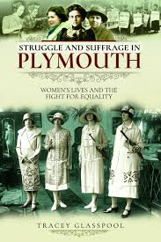](https://www.google.com/imgres?imgurl=https%3A%2F%2Fwww.pen-and-sword.co.uk%2Fassets%2Fimg%2Fjackets%2Flarge%2F16887.jpg&imgrefurl=https%3A%2F%2Fwww.pen-and-sword.co.uk%2FStruggle-and-Suffrage-in-Plymouth-Paperback%2Fp%2F15902&docid=CnYyFSVeTIJQvM&tbnid=rODx_Be1tAr_oM%3A&vet=10ahUKEwjJ59adtoriAhUoSBUIHSzzB0EQMwhAKAAwAA..i&w=404&h=607&bih=603&biw=1280&q=Struggle%20and%20Suffrage%20Plymouth&ved=0ahUKEwjJ59adtoriAhUoSBUIHSzzB0EQMwhAKAAwAA&iact=mrc&uact=8) [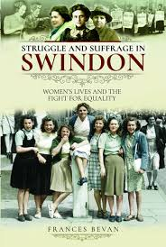](https://www.google.com/imgres?imgurl=https%3A%2F%2Fwww.pen-and-sword.co.uk%2Fassets%2Fimg%2Fjackets%2Flarge%2F17239.jpg&imgrefurl=https%3A%2F%2Fwww.pen-and-sword.co.uk%2FStruggle-and-Suffrage-in-Swindon-Paperback%2Fp%2F16224&docid=oc-up3Y4Zw0fXM&tbnid=LQXzMU-0RzTXtM%3A&vet=10ahUKEwiZvIv7tYriAhUvSRUIHYFQAEcQMwhAKAAwAA..i&w=404&h=600&bih=603&biw=1280&q=Struggle%20and%20Suffrage%20Swindon&ved=0ahUKEwiZvIv7tYriAhUvSRUIHYFQAEcQMwhAKAAwAA&iact=mrc&uact=8) **[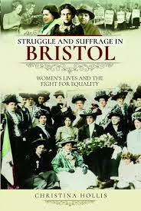](https://www.google.com/imgres?imgurl=https%3A%2F%2Fwww.pen-and-sword.co.uk%2Fassets%2Fimg%2Fjackets%2Flarge%2F16990.jpg&imgrefurl=https%3A%2F%2Fwww.pen-and-sword.co.uk%2FStruggle-and-Suffrage-in-Bristol-Paperback%2Fp%2F16000&docid=lKErCDUB2OJTSM&tbnid=h4ghQBrZZ1TaRM%3A&vet=10ahUKEwjA59GItoriAhW6TxUIHfJFD6YQMwhAKAAwAA..i&w=404&h=604&bih=603&biw=1280&q=Struggle%20and%20Suffrage%20Bristol&ved=0ahUKEwjA59GItoriAhW6TxUIHfJFD6YQMwhAKAAwAA&iact=mrc&uact=8)**

***The Origins of Photography in Salisbury 1839 - 1880***

Anthony Hamber

Hobnob Press 2019 ISBN 978 1 906978 73 0 £20

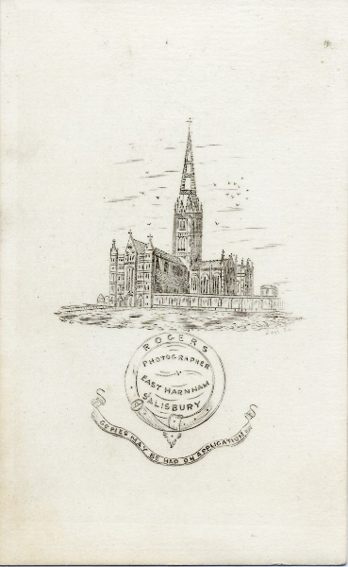This generously illustrated new book follows the exhibition of the same title at the Salisbury Museum held during the winter of 2019. There is much detailed new material on the individual professional and amateur photographers in the city at the time.

Amongst these are a small number of women, such as Mary Ann Rogers, who was described as ‘photographer’ in the 1871 census. Dr Hamber argues that it is likely that more women were engaged in various roles in the businesses, even if not named as such. Sadly, it will probably never be possible to identify them. A number of early photographers were itinerant, presumably before it was a sufficiently proven business to make a permanent location cost-effective, so we learn here about the offers of having your photograph taken in other towns too.

The chapters on ‘Commercial Photography and its Applications’ and ‘Selling, Buying and Exhibiting’ are innovative in placing the art/craft/science into the community, considering who were the photographers’ customers, and discussing how people got access to photographs in this early period. Appendices provide an excellent introduction to the history of photography, its techniques and development through the 19th century.

*Illustration: Etiquette (verso) of a carte de visite photograph thought to have been taken by Mary Ann Rogers (Anthony Hamber collection).*

***Of course, the Durham coalfield is not in our region! But this book might be of interest to those concerned with the mining communities of the south west of the UK as a comparative study.***

***Women of the Durham Coalfield in the 19th century: Hannah’s story***

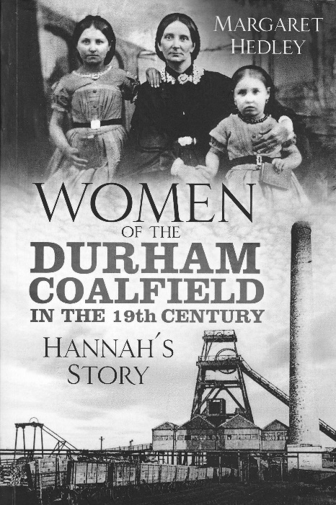Margaret Hedley

The History Press 2019 ISBN 978 0 7509 8988 6 £12.99

The coal industry of the north-east of England, as elsewhere, is well documented and the working conditions of the men underground and at the pitheads will be well-known to many readers. Less widely understood is the crucial role that the women of those coalmining families played in maintaining the households, and indeed underpinning the local economy.

In this book Margaret Hedley has used the life of her great, great grandmother to explain how vital the women were, as wives and mothers of successive generations of miners in the Durham coalfield. Their work was equally arduous, if not more so. More than one miner in the family could be working different shifts, which would require hot meals and hot baths at different times of the day, and night. Shopping, cleaning, laundry, caring for children and old people had to be fitted within this strict timetable.

The daily pattern was hard enough; but the employment system of bonds and associated tied housing involved moving the whole family at regular intervals in search of better work. Again, the burden fell largely on the women to pack up one cottage and recreate a new home elsewhere.

These lives are described with great empathy in this book. The author has used an effective interweaving of family and local history approaches to tell the story of Hannah and her contemporaries. Some readers may find the imagined conversations inappropriate, and indeed the book would make a good ‘docu-drama’, but others will welcome the personal touch they inject to the narrative.

Common experiences, such as taking the census, the impact of cholera, celebrating Sunday School outings, and so on, would apply to many working people of the 19th century and were no doubt part of Hannah’s family’s life even if there is no direct evidence of their personal participation.

I would have found a map useful, and a family tree to work out those with duplicate first names, and step-relations; and some specific references to the sources used, though there is a comprehensive bibliography but alas no index.

Hannah supplemented the family’s income by working as a seamstress and that may have allowed her to have studio photographs taken of herself and her daughters to send to her husband in Australia looking for work. One was taken in 1858 and another, illustrated on the cover, in 1862. Hannah’s skill presumably contributed the ‘best frocks’ they were wearing.

This is a fascinating book which makes a valuable contribution to regional, industrial and women’s history.

*This review was first published in* Local History News *131 Spring 2019 www.balh.org.uk/lhn*

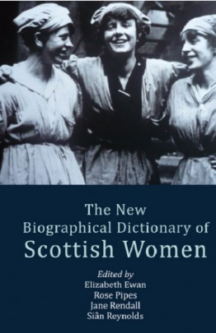

***The new biographical dictionary of Scottish women***. 2nd ed, edited by Elizabeth Ewan, Rose Pipes, Jane Rendall and Siân Reynolds. Edinburgh University Press, 2018. 544 pp; 60 illus. Pbk & e-Pub £35. Hbk & PDF £90. (ISBN Pbk 9781474436281; Hbk 978-1-4744-3627-4)

<https://edinburghuniversitypress.com/book-the-new-biographical-dictionary-of-scottish-women.html>

**The Historical Association** has established an innovative project to engage young people in the UK’s democratic history, focusing on the suffrage movement. ‘Women’s Suffrage: history and citizenship resources for schools’ can be found at http://[www.suffragesources.org.uk](http://www.suffragesources.org.uk) The website contains a searchable database of over 3,000 individuals across England supported by case studies and guidance, plus activities and resources that can be used flexibly to suit school provision and circumstances.



***Rouse, Ye Women! - A folk ballad about Mary Macarthur and the women chainmakers***

On the 17th of April at the 105-seat Rondo Theatre in Bath, John Kirkpatrick’s original music, combined with traditional folk tunes, brought the story of Mary Macarthur (1880-1921) and the women chainmakers of the Black Country to life. Covering their fight in the 1900s to gain improved working conditions and wages, it effortlessly explained the positive impact the formation of a trade union had upon the lives of the women workers, particularly those ‘hidden’ home-workers. Using the analogy, “one worker is like a stick, easy to break; a union is like a bundle of sticks bound together, and much stronger”, the play demonstrated how Mary Macarthur helped to force a change in the law to give more rights and a guaranteed minimum wage to these women.

The three versatile and engaging cast members, Neil Gore (co-writer), Rowan Godel and Bryony Purdue quickly drew the audience into the performance as ‘extras’ by encouraging a sing-along, whilst simultaneously ensuring the grit, exhaustion, and injustices of the female worker’s lives were brought powerfully to the fore. It was Purdue however, playing the part of Mary Macarthur, a middle class educated woman, that demonstrated in her passionate performance, precisely how charismatic women of the age managed to inspire others to action.

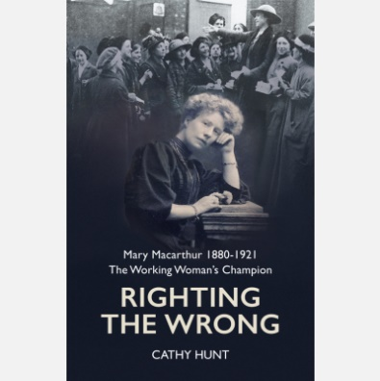Unfortunately, the tour of this performance has now ended, but to learn more about Mary Macarthur a new book is due to be published by Cathy Hunt on 1st August 2019, normal price £20. A £5 discount is available if pre-ordered from <https://www.historywm.com> before 1st June 2019.

*“This new biography by historical author Cathy Hunt seeks to understand what motivated this extraordinary individual and why she chose the path that she did, particularly at a time when it was still far from common for a middle-class woman to appear on public platforms. In other words, this is not just an account of Mary the union leader but of Mary the woman – of her travels and friendships, love and marriage, family and motherhood – explored within the context of her times.”*

**ENGLISH HERITAGE WANT MORE BLUE PLAQUES FOR WOMEN!**

“With only 14 per cent of blue plaques dedicated to women, English Heritage is calling on the public to nominate more females.”

<https://www.english-heritage.org.uk/about-us/search-news/more-blue-plaques-for-women/>

**Do tell us about blue plaques (planned or unveiled) dedicated to women in the South West and Wales region.**

**Our website**

***http://***[***www.weswwomenshistorynetwork.co.uk***](http://www.weswwomenshistorynetwork.co.uk)

Here you will find all the current and historic information about the network, including programmes and abstracts from previous conferences, papers from study days, links to other relevant organisations and much more. It will continue to develop as a valuable resource for members and friends. It’s the first place to go for details about all our forthcoming events!

Contributions are welcomed; please contact Kath Holden in the first instance   
[*katherineuna.holden@gmail.com*](mailto:katherineuna.holden@gmail.com)

 **Twitter**

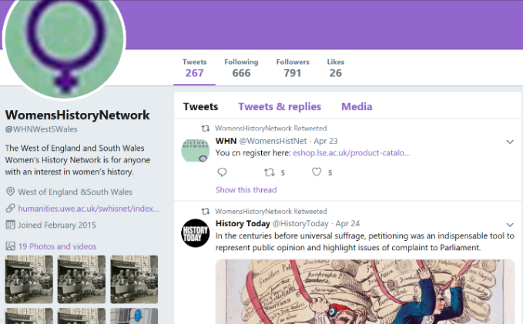

The West of England and South Wales Women’s History Network has its own **Twitter** account so you can keep up to date with events, resources, member news and articles of interest.

It’s at @WHNWestSWales and if you’re on Twitter do follow and retweet.

**Subscriptions**

Membership subscriptions are the regional network’s income. Please make sure you are paying the correct amount: the rates are £10 full or £5 unwaged/student. Subscriptions are renewable annually on 1 October. It helps us if you can pay by banker’s order.

**Membership enquires:** [*elaine.titcombe@hotmail.co.uk*](mailto:elaine.titcombe@hotmail.co.uk)

**Newsletter:**

Please send contributions and suggestions to Jane Howells, 7 St Marks Rd, Salisbury SP1 3AY [*jane@sarum-editorial.co.uk*](mailto:jane@sarum-editorial.co.uk)

