West of England and South Wales Women’s History Network
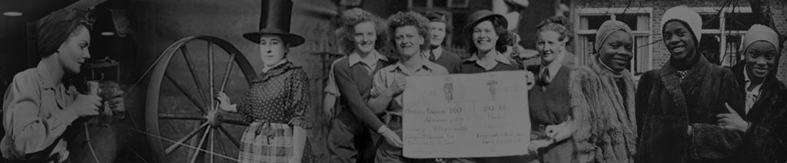
Penny Summerfield
(Emerita Professor in History at the University of Manchester)
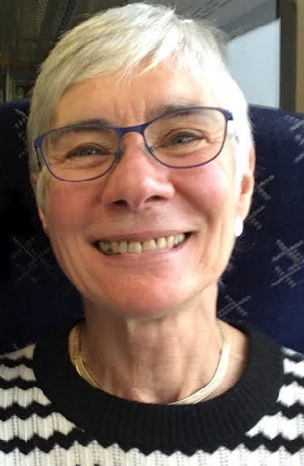

will give an illustrated talk at
The Museum of Bath at Work
348 Julian Rd, Bath BA1 2RH, UK
Friday 28th February 2020, 6.00 for 6.30pm
‘Self and Society on the British Home Front:
some women’s diaries of the Second World War’
£6 entry including a glass of wine.
All are welcome.
Please book places in advance by emailing
Katherineuna.holden@gmail.com
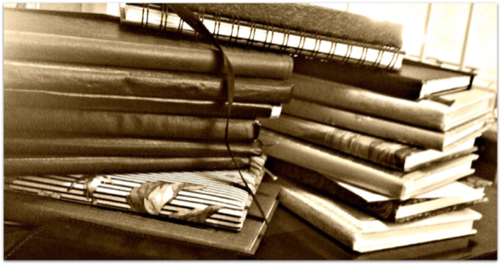

Web address: http://weswwomenshistorynetwork.co.uk/ Follow us on Twitter

