The West of England and South Wales
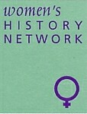

Women’s History Network

26th Annual Conference
Saturday 29th June 2019, 9.30am – 4.45pm
Followed by AGM

The University of the West of England, Frenchay Campus Coldharbour Lane,
Bristol BS16 1QY
Histories of Women in Agriculture and Rural Life
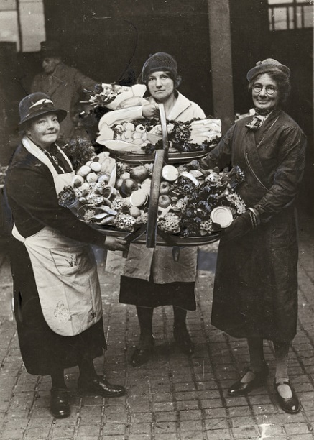
Programme

9.30 Registration
9.50 Welcome Note
10.00 Keynote: Professor Nicola Verdon, author of Rural Women Workers in 19th century England

11.00 – 11.30 Coffee break

11.30
Valerie Brenton, Dusting and Digging: The revelations of a wage ledger 1796-1829.
Carrie de Silva, The agricultural education of women from the 1880s to 1939.
Jacqueline Sarsby, Early farm tourism, borders and farm servants 1910 – 1950.

1.00 Lunch

2.00 Back to the Land
Katherine Holden, Diana Russell and Elaine Titcombe, in conversation with Lucienne Boyce, sharing their own experiences and family histories of women in agriculture and rural life.

2.45
Julia Neville, Exploring women’s lives in the ‘Deserted’ village in 1920s Devon.

3.15 Coffee Break

3.30
Kate Luck, The early development of Wiltshire’s ‘Women on the Land Movement’ during the Great War: Can Town Girls be taught to milk?
Lisa Payne Ossian, The emergency famine of 1946: An examination of farm women’s production and perceptions.

4.30 Closing Remarks

4.45 – 5.15 AGM All Welcome

For more information please email: WHNWESTSWALES@outlook.com
Web site: http://weswwomenshistorynetwork.co.uk/

