West of England and South Women's History Network
26th Annual Conference
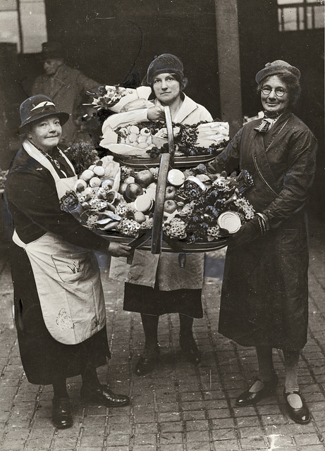
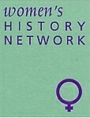
Saturday 29th June 2019, 10am – 5pm
University of the West of England,
Frenchay Campus, Coldharbour Lane
Bristol BS16 1QY
Histories of Women in Agriculture and Rural Life

Keynote Speaker: Professor Nicola Verdon, author of Rural Women Workers in 19th century England, will give an overview of work in this area with special reference to women and agriculture in the First World War.
CALL FOR PAPERS
We invite papers on any aspect of the history of women in agriculture and rural life. Topics could include:
- Farming
- The Women's Land Army
- Industrial employment in rural communities
- Family Life
- Allotments
- Women's Institute
- Protest
- Women farmers and agricultural workers
Paper proposals of not more than 300 words should be sent to Lucienne Boyce, lucboyce@blueyonder.co.uk by Monday April 15th2019.
Web site: weswwomenshistorynetwork.co.uk
Photo Eastbourne WI Market – courtesy of the Women’s Library

