‘Votes for Women' and Women's Work during the First World War in Bath and Bristol
Wednesday 28th November 2018, 7pm
Bath Royal Literary and Scientific Institute, Queen Square, Bath, BA1 2HN
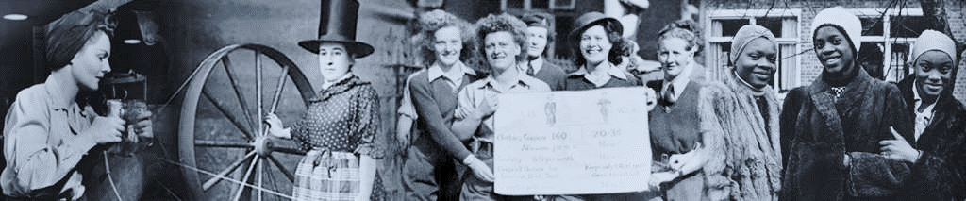
The West of England and South Wales Women’s History Network
celebrate the centennial of the Representation of the People Act 1918 with an exhibition and talks on the campaigns leading up to most women over 30 gaining the vote and the contribution of women in Bath and Bristol.
- What part did local women play in suffrage campaigns?
- What difference did women’s work during the First World War make to this achievement?
At 7.30pm talks will be given by June Hannam, Lucienne Boyce and Katherine Holden on
‘ Women's suffrage, citizenship and the 1918 Representation of the People Act:
Bath women in politics’
We will be exploring the women's suffrage campaign in Bath after 1906 and looking at the impact of war, both on the suffrage campaign and on ideas about citizenship. We will also consider the outcomes of the 1918 Act for women's politics in Bath.
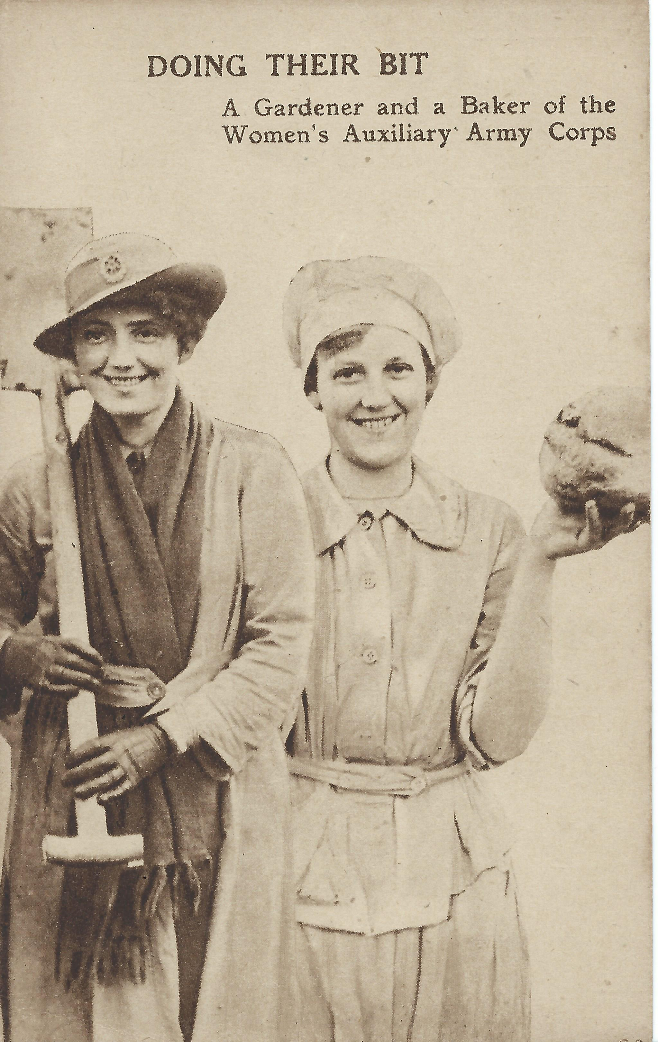
All welcome.
Entry costs £5 (£6 on the door)
including a glass of wine or soft drink.
For further information email katherineuna.holden@gmail.com
To book go to http://weswwomenshistorynetwork.co.uk/

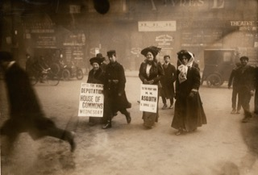

Women at work in the war
Advertising a suffrage deputation
“The Women’s Library Collection on Flickr” No Known Copyright Restrictions

