BRIDPORT WOMEN’S ACTIVISM
1910-1920
STUDY DAY, Bridport Museum, 18 November 2018
Gundry’s French machine hands on strike in 1912

‘We Want Our Rights’ asserted the banner of the young women who went on strike in Bridport in 1912.
This study day provides the opportunity to explore how Bridport women of different social classes and ages demanded their rights in the period before, during and immediately after the Great War.
The exhibition, ‘Home Front, Home’, at Bridport Museum raises some of these issues. This study day will develop some of the stories told there, and ask how does the experience of Bridport women fits into a wider picture, and how did the war affect their activism?
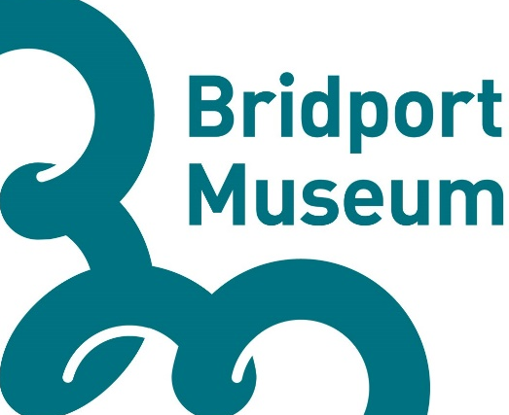
West of England & South Wales
Venue: Bridport Museum, South Street, Bridport, DT6 3NR
Cost: £10 (including coffee and cake, bring your own lunch)
Programme:
9.45 Registration, look around exhibition
10.10 Welcome (from Bridport Museum and SWWEWHN)
10.15 Session 1: Working-class women’s activism (Chair: June Hannam)
10.15 - 10.45: On the Trail of the Bridport Wildcats: Lucy Goodison and Carlos
Guarita
10.45– 11.15: Mary Macarthur and the National Federation of Women
Workers, 1906-21: Cathy Hunt
11.15– 11.30: Conversation between speakers on how does the experience of
Bridport women fit into a wider picture and how did the war affect their activism?
11.30 – 11.45: Audience Q&A /discussion

11.45- 12.00 Coffee

12.00 – 1.00 Session 2: The Making of ‘Home Front, Home’ (Chair: Cathy Hunt)
Panel: Emily Hicks (Museum Director); Nicola Kelly (volunteer researcher); Crystal Johnson (curator): Spike Golding (designer).

1.00 – 2.00 Lunch (bring own or explore Bridport’s delights)

2.00 – 3.30 Session 3: Middle-class women’s activism (Chair: Kath Holden)
2 -2.30: The Learned and Literary Ladies of Devon Suffrage: Julia Neville
2.30-3.00: Rediscovering Bridport Suffragists: West Dorset Women’ Suffrage
Society, 1910-20: Karen Hunt
3.00– 3.15: Conversation between speakers on how does the experience
of Bridport women fit into a wider picture and how did the war affect their activism?
3.15-3.30 Audience Q&A /discussion

3.30-3.45 Tea

3.45 -4.00 The future of women’s history in Bridport

To book a place on this study day please complete the attached form and either take into Bridport Museum with your £10, or post with a cheque for £10 made payable to Bridport Museum Trust, to The Coach House, Gundry Lane, Bridport, Dorset, DT6 3RJ no later than Monday 5 November 2018.

For more information please contact 01308 485703 or email director@bridportmuseum.co.uk

BRIDPORT WOMEN’S ACTIVISM
1910-1920
STUDY DAY, Bridport Museum, 18 November 2018
Booking Form

Name(s):

Address:

Email:

Contact phone number:

Signed:

Date:

I have included £10 payment yes/no

