The West of England and South Wales Women’s History Network
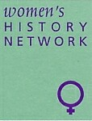
25th Anniversary Conference
Royal Literary and Scientific Institute, Queen Square, Bath, BA1 2HN
Saturday 7th July 2018 9.15am – 5pm

Women’s Networks
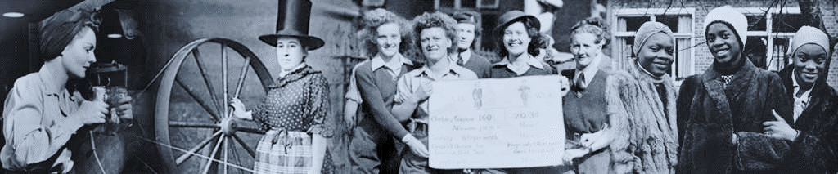
Programme
9.15 Registration
9.40 Welcome
9.45 Keynote: Caitriona Beaumont, 'Female Networks, Ageing and Identity in late twentieth century England: The Mothers' Union and female activism 1960-1980'
10.30 Coffee
11.00 Panel One: Women’s Networks and Political Agency
Ellie O'Connell, Accion and Vida: Peruvian feminist magazines of the 1970s and 80s and their transnational networks.
Joy Coates, Agents of change: Women organizing and political participation in Kenya in the 1940s and 50s

11.00 Panel Two: Print and Women’s Networks in Colonial India
Mobeen Hussain, The Indian Ladies Magazine as a site for English and Indian relations and transatlantic exchange (1901-1938)
Arti Minocha, Print and women's networks in colonial Punjab

12.00 Panel Three: Community Networks and Social and Political Change
Mark Benson, " I was speaking to a neighbour...she told me that she knew a woman who could relieve me": Female networks and the acceptance of abortion for 'social' reasons in Northern Ireland 1900-1968.
Christine Chapman, Family, teachers and chapel: networks which supported and undermined young women’s engagement with education in mid-twentieth century Rhondda.
12.00 Panel Four: Civil Life and Political Activism
Karen Hunt, Women’s networks on the Dorset home front, 1914-19
Carmen Mangion, The Catholic Women's Suffrage Society and its reform agenda
1.00 Lunch
2.00 Panel Five: Literary and Epistolary Networks
Jane Howells, Interlocking networks in the tragically short life of Maud Francis Davies (1876-1913): support or challenge?
Linda McGuire, Born to write: inherited eloquence and female literary networks in Ancient Rome
Rachel Smith, "You are now mistress of your own pen": the epistolary network of the Canning family circle and its impact on the education of Elizabeth Canning's letter writing

2.00 Panel Six: Feminism and Women’s Networks
Di Parkin, Networking and letters from 1970s
Sue Tate, Just Women Magazine (1987-97): A rural endeavour
Cheryl Morgan, Who gets to be a feminist?

3.30 pm Tea

3.45 pm Key Note: June Hannam and Katherine Holden, Building a Network: A history of the West of England and South Wales Women’s History Network
4.30 AGM
5.00 Close

For more information contact Katherine.Holden@uwe.ac.uk Web site: http://weswwomenshistorynetwork.co.uk/

