The West of England and South Wales Women’s
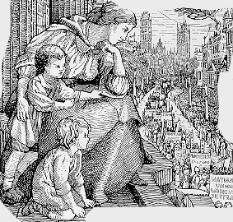
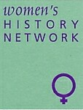
History Network
25th Annual Conference

Saturday 7th July 2018

Royal Literary and Scientific Institute, Queen Square, Bath, BA1 2HN
10am – 5pm

Women’s Networks
Keynote Speakers: Catriona Beaumont, June Hannam and Katherine Holden

On our 25th anniversary year we will be exploring the importance of networks in women’s lives over time and space, whether local, national or international. Networks can empower and support women as individuals as well as effecting political and social change. We invite papers on any aspects of women’s networks in their historical context.
Networks could be formal such as political organisations, trade, professional, philanthropic and religious associations or informal, including family, friendship, community and neighbourhood groupings.
Speakers might want to consider questions such as:
- Why were women-only groups set up?
- What forms did they take?
- What were the processes in networks’ formation?
- The significance of leadership
- Relationships between central and local organisations
- Writing letters as a form of networking
- The role of newspapers, journals and newsletters in networks
- Inclusion and exclusion in networks

Paper proposals of not more than 300 words should be sent to June Hannam June.Hannam@uwe.ac.uk by 28th February 2018

