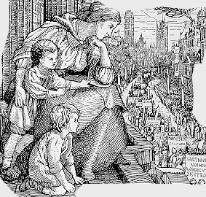
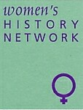
The West of England and South Wales
Women’s History Network 24th Annual Conference
held in conjunction with Llafur - The Welsh People’s History Society
The Llewellyn Suite, Coleg y Cymoedd, Aberdare Campus
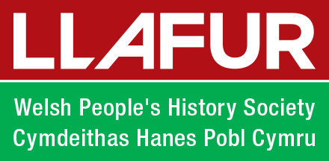
Cwmdare Road, Aberdare, Rhondda Cynon Taff, CF44 8ST
Saturday 1st July 2017, 10.am to 5.30pm

Women and the Labour Movement in Britain from 1880 to 1950

From 9.30 Registration
10. 00 Welcome
10.10 Key Note Talk Karen Hunt, Keele University, ‘Labour and the Housewife’
11.00 Coffee/Tea
Panel One: Women and Socialism 1880-1918
11.30 Martin Wright, Cardiff University, Socialist women in Wales 1880-1914
12.00 Alison Ronan, Manchester Metropolitan University, Film and talk on suffrage peace crusade
12.30 June Hannam, UWE Mabel Tothill- from peace activism to local councillor
1.00 Lunch
2.00 Key Note Talk, Stephanie Ward, Cardiff University, ‘Political Activism and the Political Self in Interwar Working-Class Women’s Politics’.
Panel Two: Women and Political Activism in the Interwar Years
2.45 Daryl Leeworthy, Swansea University, ‘Democracy in the Nursery: Labour Women and the Struggle for Early Year Education in Interwar Bristol and South Wales’
3.15 Lucienne Boyce, Bristol independent scholar and author, “The Dignity of Womanhood”: Olive Beamish (1890–1978), Typist, Trade Unionist and Labour Activist
3.45 Coffee/tea
4.00 Chorfi Fatima, University of Mohamed Ben Ahmed, Algeria, ‘The Labour Party, The Real Women’s Party, 1918’
4.30 Women’s History Network AGM
5.00 close

