The West of England and South Wales Women’s
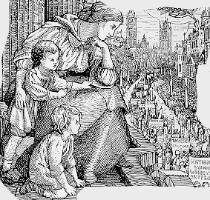
History Network
23rd Annual Conference
Saturday 18th June 2016

Royal Literary and Scientific Institute, Queen Square, Bath, BA1 2HN
10am – 5pm
Women and the Arts in Historical Perspective
Programme
9.30 Registration
10-11.00 Keynote speaker
Rebecca D’Monte : ‘War Stories: Female Literary Responses to the Two World Wars’.
11-11.30 Tea/Coffee
11.30-1.00 Panel 1
Vivien Newman: ‘”Women Like That”: Women’s Poetry from the First World War’s Forgotten Fronts’.
Nesta Jones: ‘Rose Elizabeth Burford: Pioneer, Innovator, Artist’.
Shan Morgain: ‘Mabinogi Sisterhood, intimate parallels across five centuries: Rhiannon, mythic queen of mediaeval Dyfed and her Victorian publisher Charlotte Guest’.
1-2.00 Lunch
2-3.30 Panel 2
Sarah Whittingham: ‘“I do not think I should favour one of my own girls taking it up as a profession”: Eveline Dew Blacker (1884-1956), Bristol’s First female Architect’.
Jacqueline Sarsby: ‘Therese Lessore, Louise Powell, Barron and Larcher in Gloucestershire: The Women’s Network in the Cotswold Arts and Crafts Movement’.
Sue Tate: ‘Women Pop Artists and the Disruption of Art History’.
3.30- 4.00 Tea/Coffee
4.00 AGM
For further information about the conference contact Katherine.Holden@uwe.ac.uk or June.Hannam@uwe.ac.uk
Women and the Arts in Historical Perspective: 18th June 2016
Booking form

NAME

ADDRESS

EMAIL

TELEPHONE

REGISTRATION (includes morning and afternoon tea and coffee and biscuits)

High waged £15 □
High waged members of regional network £13 □
Low waged/students £10 □
Low waged/students members of regional network £8 □

Lunch is not included. Bring your own sandwiches or there are lots of cafes nearby.
Please tick relevant boxes and enclose a cheque for the total £……………….. payable to Southwest Women’s History Network
Please let us know if you will require assistance for access
Send your cheque and this completed form to Professor June Hannam, 2 Malvern Villas, Camden Road, Bath BA1 5JS Enquiries to Katherine.Holden@uwe.ac.uk
http://humanities.uwe.ac.uk/swhisnet/index.html

