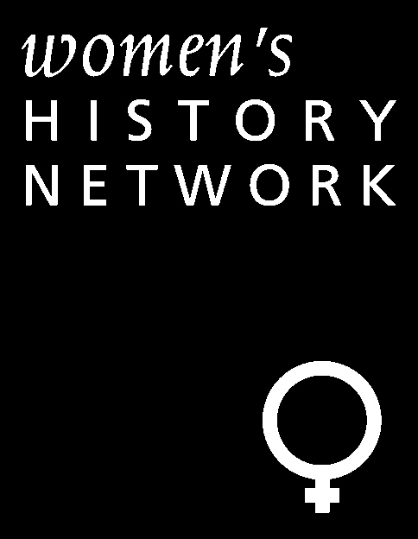

STUDY DAY
SATURDAY 25 APRIL, UNIVERSITY OF GLAMORGAN
G305, G304 from 10.30 till 3.00

IN RESPONSE TO WAR: WOMEN, WORK, AND MEMORY IN THE TWENTIETH CENTURY

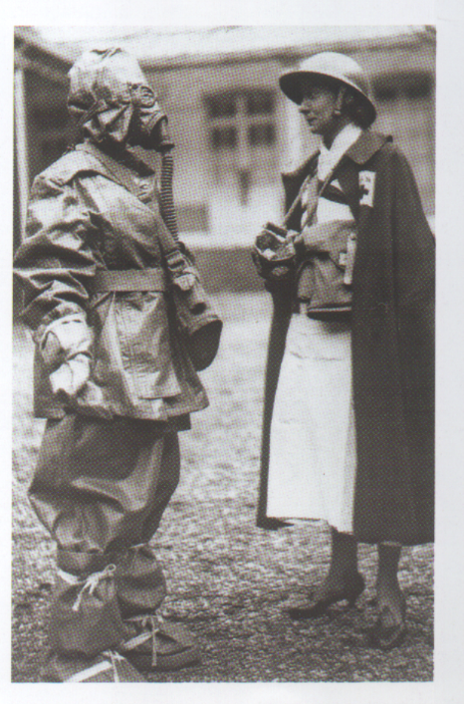

Gill Abousnnouga, (University of Glamorgan) ‘The representation of women in the war monument: a multimodal approach’

Sharif Gemie (University of Glamorgan) ‘Women, Welfare and Refugees: Displaced Persons and UNRRA (1944-48)’

Tracey Loughran (University of Cardiff) ‘The historiography of trauma and gender in the First World War’

Helen Steele (University of Swansea) ‘Daily Life in National Socialist Austria’

ALL WELCOME
THIS EVENT IS FREE

Ffi: Fiona Reid, University of Glamorgan, freid1@glam.ac.uk.

