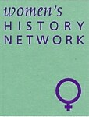
Women Health and Welfare
The West of England and South Wales Women’s History Network 10th Anniversary Conference
Saturday 26 June 2004
University of the West of England, HLSS Faculty, St Matthias Campus, Oldbury Court Road, Fishponds, Bristol BS16 2JP

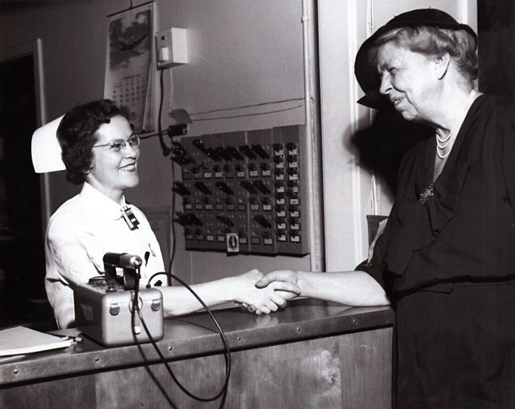

Plenary Speaker:
Maria Luddy, The Welfare of Unmarried Mothers in Ireland in the early Twentieth Century

Other speakers include Kay Saunders, Christi Keating Sumich, Emily Payne, Jane Howells, Carrie Howse, Pamela J Wood, Maralyn Foureur, Margaret Ritchie, Linda Walker, Cynthia Hammond, Sile O’Connor,
Kath Holden, Pamela Dale, Moira Martin and Stephanie Kirby

Further information can be obtained from:
Katherine Holden tel 0117 344 4395 email Katherine.Holden@uwe.ac.uk,
June Hannam, email: June.Hannam@uwe.ac.uk or Fiona Reid. email freid1@glam.ac.uk

